Experiment with ChatGPT

This is a mere experiment with ChatGPT to showcase how we can leverage the power of AI to boost our productivity. In this document I have shown how to brainstorm with ChatGPT and derive a solution from it.
Though the results are impressive, there are major issues that one may face if he or she decides to use AI models such as this without proper understanding of software development.

But in contrast, these actually can be used as significant productivity boosters for those who know what they are doing.

I am posting my initial analysis below that I did without the help of ChatGPT so that we can observe what ChatGPT does well and where it lacks.

There is one big issue that causes slowness in the code
- The 'grantVacation' function iterates through an array of payroll objects and in each iteration it goes into 2 inefficint operations to fetch address information and employee information by looping through arrays 'addresses' and 'employees'. It takes O(n) time to fetch them from those arrays in a given iteration of the outer loop.

Hence the overall time complexity of 'grantVacation' function becomes O(n^2) as it has this nested loop situation.
If we use a different data structure other than arrays which we can use to fetch address and employee information in O(1) time, we can fix this slowness.
I have provided an alternative implementation for this in python language using dictionaries which has a O(1) lookup time.

I also spot two other minor issues in the implementation.

- The function 'yearsSince' gets called for each payroll inedx and it calculates millisecondsPerYear variable each time. It can either be replaced with its value inplace or the value can be obtained from a predefined global level constant.

- Assuming we are sending the emails in a single day, we don’t need to create a new Date() object in each iteration while looping the payroll

There is a small implementation detail that I would like to highlight is as below
const yearsEmployed = yearsSince(empInfo.endDate, today);

The above line is as per the original code provided in the assignment
But I believe the line should be amended as below
const yearsEmployed = yearsSince(empInfo.startDate, today);

Q1.
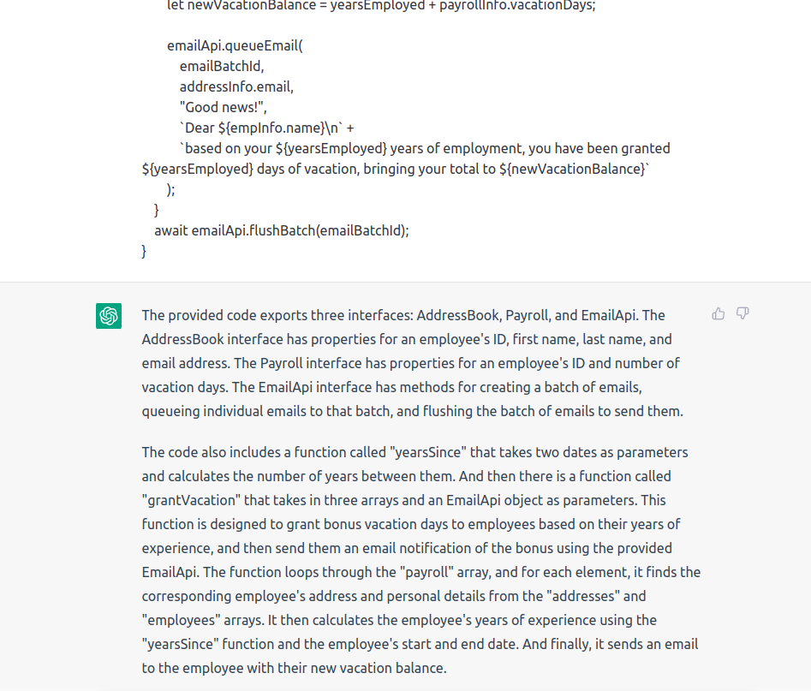
This is where I initially pasted the code and it correctly describes the functionality, which is very Impressive.

Q2.
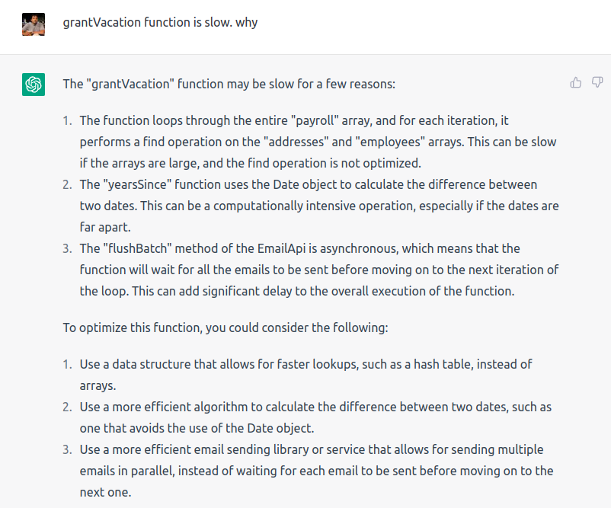
Here I ask the reason for the slowness by giving a pre-context to it. I say its slow and ask why from it.

It outputs 3 reasons.
- Reason 1 is correct.
- Reason 2 is not correct. I am not familiar with typescript but I can clearly understand that there is no need to do value iteration to derive the number of days. Hence the dates being far apart is not a concern here.
- Reason 3 can be partially true. But we have no reason to debug the email sending functionality. Besides, flush function is not called under a loop and ChatGPT has got that point wrong. The function simply sends out a batch in each call.

ChatGPT even outputs possible solutions as well and that is really helpful.

The bottom line here is that the user should be knowledgeable enough to filter out what’s right and wrong.
But on the plus side, it draws the user’s attention into different directions and it really helps at a level of brainstorming.

Q3.
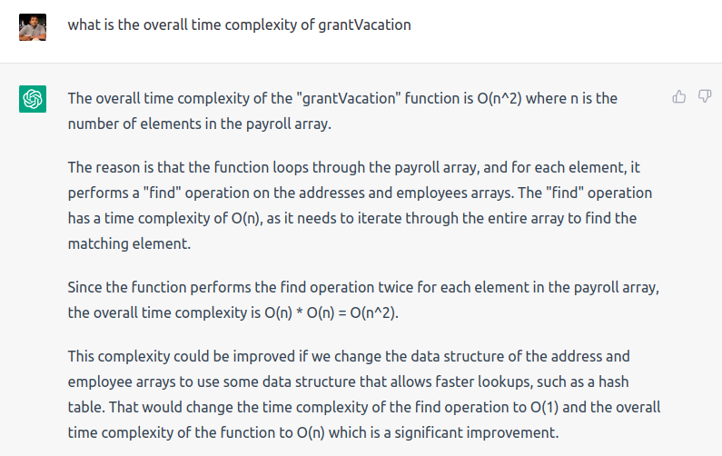
It is right about the time complexity. It also goes an extra step and suggests that we use hash tables instead of arrays to improve performance without even being asked. How impressive!!

Q4.
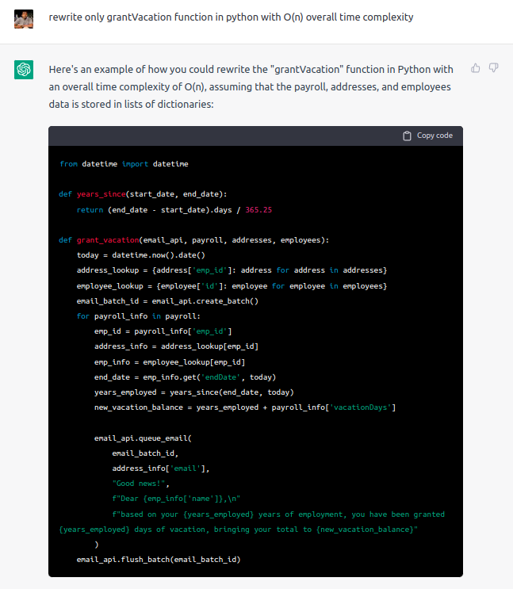
Now this is the tricky part. If a user tries to simply copy paste ChatGPT code, a lot of things can go wrong.

- Firstly it has completely forgotten the async-await usage that it originally had
- Secondly, it automatically assumes that we are providing an array of dictionary objects instead of python objects
  - What if we try to generate the whole code instead of the individual ‘grant_vacation’ function? Would it replace nested dictionaries with Python objects, as it has more context now than before? Actually yes. Please see the below example that I created to showcase just that.
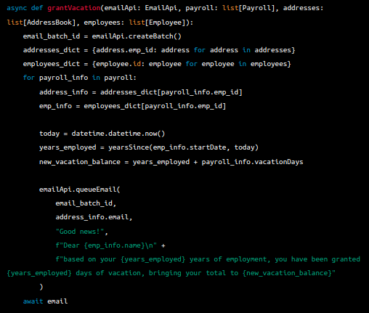
    - It created classes and lists of objects properly. It even fetches properties from the objects properly to populate the dictionaries.
    - But the generated function was a partially generated one. (check the await line)
    - Also note that here it actually has included async-await as it sees more context overall

- On the plus side,
  - it has included a pre-calculated float literal value for year_since function
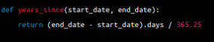

  - It also has moved ‘today’ date creation out from the loop
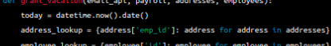

Q5.

Additionally we can do things such as making the dictionaries to be passed as arguments

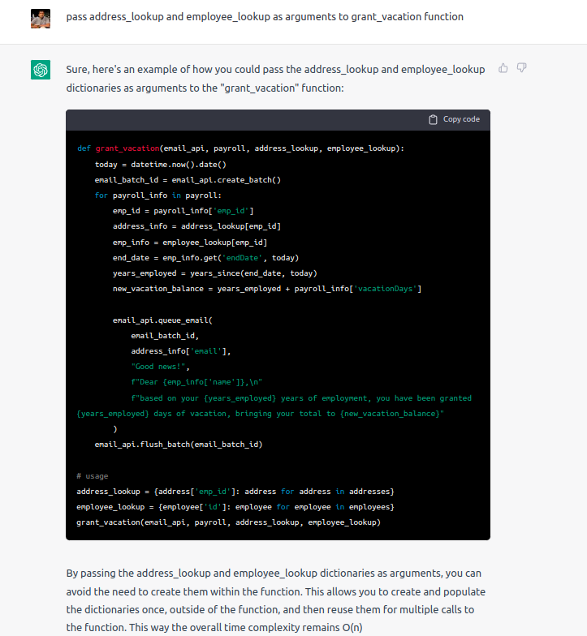

Conclusion
As I have demonstrated above, it takes only a few minutes to generate insights about code and simple functionalities out of the box. This actually means that developers now could spend more time on solving the real business problems rather than worrying about trivial functionalities. I personally see this as a great productivity booster. One great use case would be unit test case generation.
Some developers fear the rise of AI as they think AI might eventually replace their jobs. But in reality AI will not replace them. But if they don’t use AI, someone using AI might replace them as those who use AI will be far more productive than a traditional developer. In fact, developers already use stack overflow to seek aid for the code that they write which is pretty much analogous to usage of AI for code generation (use with caution).
I also believe that organizations in general should be more aware and align themselves to be more productive with the help of AI. There should be proper frameworks to encourage and guide the developers to use AI efficiently in their daily tasks.
As developers, we should understand that these tools are not going away and they are here to stay. Organizations will eventually catch up with this and would start expecting more productivity from developers as some part of their burden is being taken over by AI. So, its very important that we as developers become familiar with these tools.
Finally the bottom line is that from the organizations side, they should think about how to align their goals and strategies and how to gain an edge with the help of AI. And from the developers side, they should correctly identify what are the important skills that they should focus on improving in order to thrive in the era of AI.

